February 18, 2022
Associate Professor Luke Wilson
Chair, Arts and Sciences Curriculum Committee

Re: Approval of Changes to the Bachelor of Arts Education with Licensure (BAE)

Dear Luke and Members of the Arts and Sciences Curriculum Committee,
At its meeting on Thursday, January 27, 2022, the Arts and Humanities 2 Panel of the ASC Curriculum Committee approved the proposed changes to the Bachelor of Arts Education with Licensure program. This is the Department of Arts Administration, Education & Policy’s (AAEP) Educator Preparation Program.
The proposed changes do not have any effect in the required credit hours, but rather offer a more well-rounded program of study that will allow students to fulfill their existing requirements. Some of these changes provide more options for courses with no pre-requisites such as ART-3107 Life Sculpture; ART- 3101 3-D Modeling or ART-3003 Introduction to Glass Art or eliminate courses that duplicate content such as EDUTL 4005-Urban Teaching & Learning or courses that will be shelved under the new GE roll-out such AE 2520 Digital Artmaking.
Finally, the department proposed some Course title changes to better reflect current educational trends (i.e., Disability and Inclusive Practices instead of Special Needs), and to make the course content more explicit for students. The department will make the corresponding changes to advising sheets for clarity.
We believe that the proposed revisions aligned with the rigor of the College of Arts and Sciences, and the modifications to the curriculum sheets offer clearer understanding of the requirements for the BAE degree program for students and advisors. Thus, we advance the proposed revision to the Arts and Sciences Curriculum Committee with a motion to approve.
Regards,
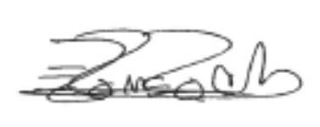
Eugenia Romero, PhD
Associate Professor of Iberian Studies
Vice-Chair and Director of Undergraduate Studies
Department of Spanish and Portuguese

